6COSC023W
Computer Science Final Project

Project Proposal and Requirements Specification (PPRS)
Handout
A sound recognition system for monitoring safety at workplaces

Student: Dat Quang Pham (20992053)

Supervisor: Bob Nguyen

Degree: BSc (Hons) Computer Science

School of Computer Science & Engineering
College of Design, Creative and Digital Industries
University of Westminster

13-11-2025

Declaration

This document has been prepared based on my own work. Where other published and unpublished source materials have been used, these have been acknowledged in references.

Student Name: Dat Quang Pham
Date of Submission: 13-11-2025

Definition of the Problem
- Problem Description:
Workplace safety remains a critical concern across UK industries, particularly in high-risk sectors such as construction, agriculture, and manufacturing. According to the Health and Safety Executive [1, 10], there were 604,000 non-fatal injuries in 2023/2024 and 124 fatal injuries in 2024/2025, costing the UK economy over £20 billion annually through direct costs (medical treatment, compensation) and indirect costs (production delays, insurance premiums, legal proceedings).
Current workplace monitoring systems predominantly rely on manual supervision by safety officers and CCTV camera surveillance. However, these approaches suffer from critical limitations: manual supervision cannot continuously monitor all areas simultaneously, while CCTV systems have inherent blind spots in complex industrial environments and require constant human attention to identify developing hazards. Neither approach can detect acoustic warning signs—equipment malfunctions producing abnormal sounds (grinding bearings, overheating motors), structural failures generating stress sounds (creaking scaffolds, cracking materials), or worker distress calls in noisy environments—that often precede visible incidents by minutes to hours, resulting in delayed emergency response.
- Significance:
This project addresses these limitations through an automated acoustic monitoring system that detects workplace hazards via sound event classification. The proposed system employs deep learning-based audio analysis to identify five critical hazard categories: equipment malfunctions (grinding bearings, overheating motors), falling objects and collisions (impact sounds), structural failures (creaking scaffolds, material stress), worker distress signals (calls for help in high-noise environments), and emergency alarms (fire alarms, evacuation signals). Upon detection, the system triggers multi-channel alerts (visual, audio, network notifications) to enable rapid intervention within the critical first 60 seconds when outcomes remain modifiable

Aims, Objectives, and Scope
- Aim: Design and implement a real-time workplace safety monitoring system using sound event detection to identify dangerous workplace sounds including equipment malfunctions, falling objects, structural failures, worker distress signals, and emergency alarm and deliver immediate alerts to enable rapid intervention.
Objectives:
- Function: Design and implement a real-time workplace safety monitoring system using sound event detection to identify dangerous workplace sounds including equipment malfunctions, falling objects, structural failures, worker distress signals, and emergency alarms and deliver immediate alerts to enable rapid intervention in high-risk environments such as construction sites, manufacturing facilities, and warehousing operations.
- Performance Targets: Develop and train a deep learning model for accurate classification of workplace hazard sounds using transfer learning from pretrained audio networks.
- Demonstrate system scalability by optimizing the trained model for deployment on low-cost edge computing hardware following successful desktop implementation.
- Scope:
  - Inclusions:

    - Real-time audio classification in constrained workplace environments (office buildings, warehouses, manufacturing facilities)
    - System can detect and recognise hazardous acoustic events such as:
Emergency alarms and sirens
      - Human distress sounds (shouting, screaming, calls for help)
      - Object collision and impacts (falling objects, crashes)
      - Glass breaking and structural failures

    - Continuous audio monitoring with event logging and timestamping
    - Daily sound event recording and storage for historical analysis and incident investigation
    - Alert notification system (visual, audio, network-based notifications to monitoring department)
    - Deployment limited to indoor workplace environments with controlled acoustic conditions

  - Exclusions:
    - Environment limitations:
      - Outdoor environment deployment (open-air workplaces, construction sites, outdoor events)
      - Extremely high-noise environments (factories with >85dB sustained noise, stadiums, concerts, outdoor festivals)
      - Variable weather conditions (rain, wind, thunder affecting outdoor audio quality)
    - Acoustic Event Limitations:
      - Fire/flames in early stages (crackling sounds often <40dB, masked by ambient noise)
      - Gas leaks (inaudible or ultrasonic frequencies beyond detection range)
      - Slow structural degradation (gradual cracking, imperceptible acoustic changes)
      - Chemical reactions without audible manifestation

Background Review
- Key Findings (Literature / Systems):
After researching current literature, I identified key features in sound event detection:
- Contemporary audio classification research demonstrates a clear trend toward CNN-based architectures [2, 3, 5, 6]. CNNs excel at extracting high-level features invariant to local spectral and temporal variations, while RNNs capture longer-term temporal dependencies within audio signals. Recent work has shown that hybrid CRNN architectures, combining the spatial feature extraction capabilities of CNNs with RNN temporal modelling, achieve significant performance improvements, absolute gains of 6.6% and 13.6% in frame-based F1 scores compared to CNN and RNN, respectively approaches [11]. This finding motivates the proposed system's adoption of CRNN architecture for workplace sound event detection.
- Audio preprocessing employs log-mel spectrograms, a 2D time-frequency representation that transforms 1D waveforms into 2D matrices compatible with CNN processing. Comparative studies demonstrate that audio-specific CNN architectures (e.g., VGGish, YAMNet) pre-trained on large-scale audio datasets substantially outperform image-based CNNs (e.g., ImageNet pre-trained models) for audio classification tasks [6]. Tsalera et al. report that sound CNNs achieve 96.7% accuracy on UrbanSound8K with 80% faster training time compared to image CNNs requiring extensive data augmentation [6]. This evidence supports the selection of audio-specific pre-trained models (PANNs, YAMNet) as transfer learning baselines for this project.
- Existing audio classification research relies on generic environmental datasets: YouTube-100M (30,871 labels) [2], AudioSet (527 classes) [3], UrbanSound8K (urban sounds) [5], and specialized single-equipment datasets (air compressor) [6]. However, these datasets lack representation of workplace safety-critical sounds—equipment malfunctions producing abnormal acoustic signatures (grinding bearings, overheating motors), structural failures generating warning sounds (creaking scaffolds, cracking materials), and worker distress signals (calls for help) obscured by industrial ambient noise (>80dB). This domain gap is significant: HSE UK reports 604,000 non-fatal workplace injuries annually [1], many preceded by detectable acoustic signatures, yet no public audio dataset specifically targets workplace operational hazards. This project addresses the gap through two approaches: (1) mapping existing dataset classes to workplace-relevant proxies (e.g., gunshot → collision, siren → alarm), and (2) collecting custom workplace-specific audio samples during deployment for domain-specific fine-tuning. The resulting system focuses on five hazard categories absent from existing research: equipment malfunction, falling objects/collision, glass breaking/structural failure, human distress, and emergency alarms.
- Transfer learning has emerged as a critical technique for reducing computational requirements in audio classification. Tsalera et al. demonstrate that fine-tuning pre-trained audio models reduces training time by approximately 80% compared to training from scratch, while maintaining or exceeding baseline accuracy [6]. This efficiency enables rapid experimentation and reduces GPU infrastructure requirements, particularly beneficial for resource-constrained research environments.
- State-of-the-art pre-trained audio models achieve strong benchmark performance. Kong et al.'s PANNs system attains mean Average Precision (mAP) of 0.439 on AudioSet's 527-class taxonomy [2], while audio-specific architectures (VGGish, YAMNet) demonstrate superior transfer capabilities compared to image-based models for audio classification tasks [6]. These models provide robust feature extractors for downstream applications with limited labeled training data.

- Comparison with Similar Software Applications/Products

Product 1: SONITROL Audio Intrusion Detection System [7]
Strengths:
    - Proven reliability with 187,000+ apprehensions: Human-verified alarms achieve lowest false alarm rate in industry (80% fewer than average), leading to 8-minute average police response
    - Comprehensive volumetric coverage: Wall-to-wall, floor-to-ceiling audio detection detects intrusions before entry (glass breaking, door prying), unlike motion sensors limited to specific points
Weaknesses:
    - No AI/ML capabilities: Entirely human-dependent verification creates 8-minute delay; cannot autonomously classify sound events or operate without monitoring station connection
    - Limited to security intrusion only: Focused exclusively on break-ins/theft; does not detect workplace safety hazards (equipment failures, worker distress, structural issues)
Product 2: March Networks AI Series Smart Cameras with Audio Monitoring [8]
Strengths:
    - Integrated multi-modal surveillance: 4MP cameras combine video analytics, AI-powered people/vehicle detection, and audio monitoring in single device with no additional licensing fees
    - NDAA-compliant with edge processing: Built-in analytics run on-camera for real-time threat detection (gunshots, glass breaking, aggression) meeting government security standards
Weaknesses:
    - Very high cost with cloud dependency: $500-1500+ per camera with best features requiring cloud subscription and constant internet; primarily video-centric design treats audio as secondary add-on feature
    - Not workplace safety-focused: Generic audio detection (gunshots/glass break) lacks training for industrial hazards; cannot detect equipment failures, worker distress signals, or operational anomalies

Product 3: IPVideo HALO Smart Sensor [9]
Strengths:
    - AI-powered keyword and aggression analytics: Machine learning identifies threats through keyword alerts (bullying, help calls) and aggression detection via voice tone analysis in real-time
Weaknesses:
    - Limited to education-focused keywords: Optimized for school environments (bullying, vaping); cannot classify diverse workplace hazards like equipment malfunctions, structural failures, or operational sounds

  - Differentiation:
- Commercial Products
Feature | SONITROL | March Networks  AI | IPVideo HALO | My Project
Primary Function | Intrusion detection | Video surveillance + audio | Multi-hazard sensor | Workplace safety monitoring
Technology | Impact-activated audio sensors | AI camera + microphone | AI audio analytics + sensors | Deep learning sound classification
Sound Detection Method | Human verification | Threshold-based (dB levels) | ML keyword/aggression | CNN/CRNN trained on workplace sounds
AI/ML Capabilities | None | Limited (video AI, basic audio) | Yes | Yes
Sound Event Types | Glass break, door/window breach | Gunshots, glass break, aggression | Gunshots, aggression, keywords | Equipment failures, distress signals, alarms, collisions, glass break
Real-time Classification | No | No | Yes | Yes
Deployment Platform | Proprietary hardware + central station | Enterprise cameras + cloud | Proprietary sensor + cloud | Laptop/PC  (Mandatory)  Raspberry Pi 4 (Optional)
Hardware requirements | Proprietary sensors | IP cameras + microphones | Proprietary sensor | Standard laptop or RPi 4
Installation Effort | High (professional) | High (professional) | Medium (semi-pro) | Low(software install)
Accuracy | Human verification (high) | Not specified | Not specified | Target: >90% on workplace sounds
Target Environment | Security intrusion | Retail, banking, transit | Schools, public restrooms | Offices, warehouses, factories
Table 1. Commercial Products Comparison

After researching commercial products, there are some key points that I identified:
    - Real-time classification is not applied to monitoring commercial products, this can cause late intervention when incidents/accidents happened
    - Gunshots, aggression keywords will be implemented to my datasets collection
    - Expense edge devices have been used in almost products on marketplace nowadays, my project initially deployed on Laptop/PC platform, which is much cheaper, then if I have enough time, I’m planning to deploy it on Raspberry Pi 4 to serve for small/medium scale business.
    - My system will apply CNNs/CRNNs to automatically analyse and statistic data and accuracy.

Tools (Hardware/Software)
- Hardware:
    - Laptop/PC (Mandatory)
    - Raspberry Pi 4 (Optional)
- Software:
    - VS Code, Jupyter Notebook: Code Editor
      - VS Code has variety of extension so it’s a good choice for audio detection project
      - Jupyter Notebook is the best for version control and debug
    - Python: Program language
      - Python is a popular language programming for Machine learning, which is providing many built-in libraries for audio detection project such as Librosa, Pyaudio for audio input processing, TensorFlow, PyTorch for Machine Learning Framwork or Numpy, SciPy, Pandas for historical data analyse purpose
    - TensorFlow, PyTorch: ML Framework
    - Librosa, Pyaudio: Audio input processing
    - NumPy, SciPy, Pandas, Matplotlib, Seaborn (Optional): Using for historical data analyse
    - Github: Version Control

Use Cases and Diagrams
Diagram. 1: System Architecture
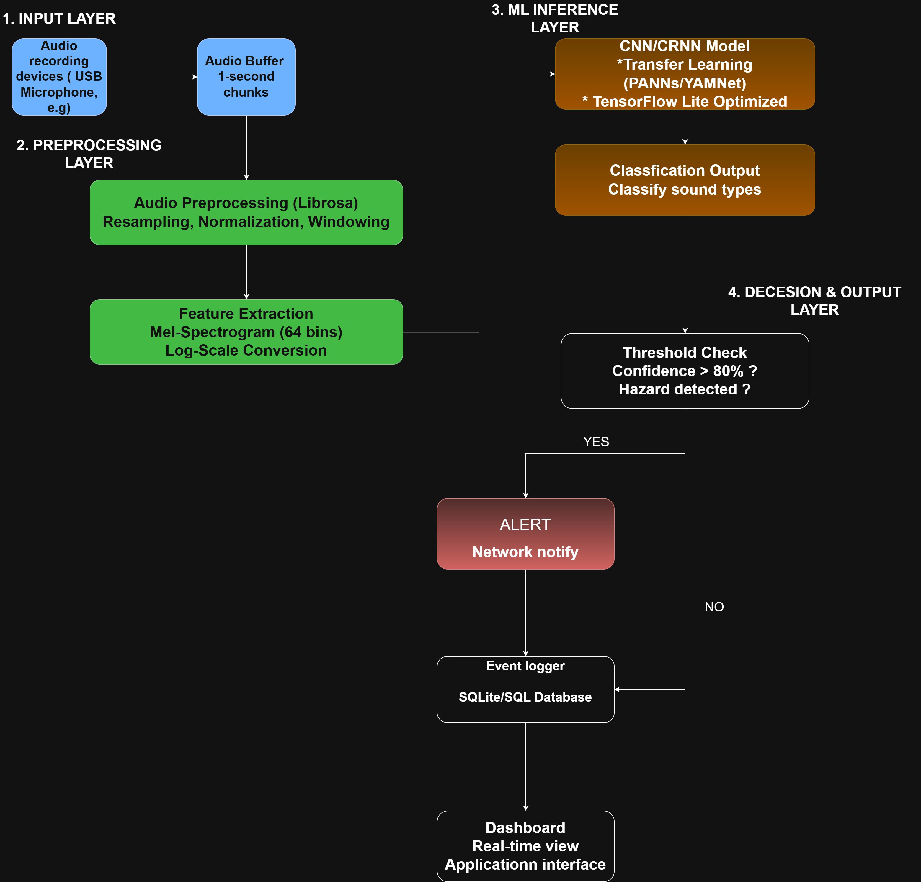

Diagram. 2: Data Flow
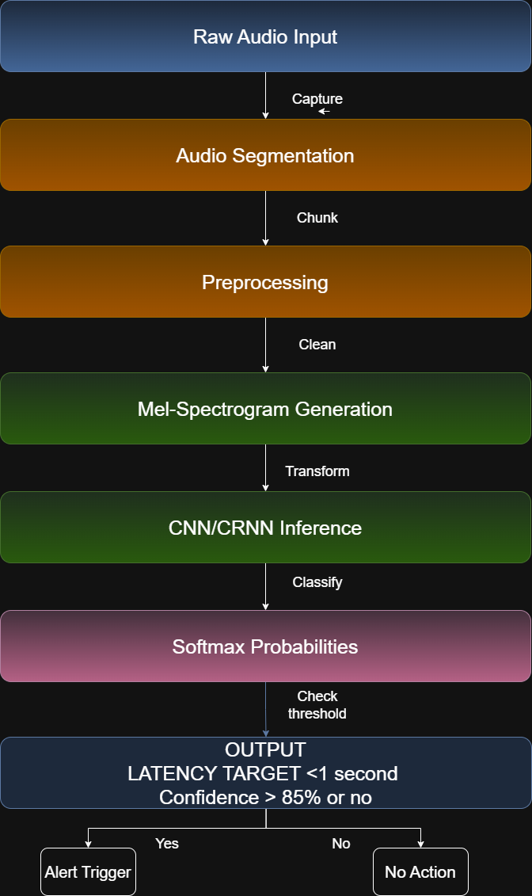

Requirements Elicitation
- Approach:
Method 1: Literature Analysis
Literature reviews on many papers as (Hershey et al. 2017, Kong et al. 2020, Elangovan et al. 2021, Mu et al. 2021, Tsalera et al. 2021) established technical benchmarks and feasibility. This revealed state-of-the-art models achieve 87-95% accuracy on standard datasets, real-time inference requires <1 second latency, and transfer learning reduces training time by 80% while maintaining accuracy. These findings confirmed the technical viability of achieving >90% detection accuracy with <1 second latency on resource-constrained hardware.
Method 2: Competitive Analysis
Three commercial workplace safety products were evaluated (SONITROL, March Networks, IPVideo HALO) to identify market gaps and best practices. Key insights included cost barriers ($500-1500 per unit), privacy concerns with video surveillance, domain gaps (security-focused rather than workplace hazards), and cloud dependency issues. These limitations directly informed requirements for edge-based processing, audio-only monitoring, and <$150 cost target.
Method 3: Regulatory Review
UK workplace safety regulations and GDPR requirements were analyzed to ensure legal compliance. HSE UK statistics (565,000 annual injuries, £20 billion economic cost) established problem severity, while GDPR data protection regulations mandated privacy-preserving design requirements including on-device processing and no cloud audio uploads.
Method 4: Public Dataset Collection and Analysis
Public audio datasets were identified and evaluated to support model training and validation. Three primary datasets were selected: UrbanSound8K (8,732 labeled sound excerpts, 10 classes including glass breaking and sirens), ESC-50 (2,000 environmental sound clips covering 50 classes), and AudioSet subset (large-scale audio dataset with 527 classes used for pre-trained model development). Dataset analysis revealed coverage of relevant workplace sounds (impacts, alarms, human voices) but identified gaps in domain-specific industrial sounds (machinery failures, structural stress), necessitating custom data collection for fine-tuning. These datasets provide baseline training data and establish benchmark comparisons with existing research.
- Techniques:
Academic Database Search: Google Scholar, IEEE Xplore, and ArXiv were used to identify state-of-the-art audio classification methods, yielding 5 core papers and 15+ supporting references
Competitive Intelligence: Product websites, case studies, and technical datasheets were analysed to understand existing solutions and identify market gaps
Regulatory Analysis: HSE UK reports, GDPR documentation, and ISO standards were reviewed to ensure legal compliance and safety standard adherence
Public Dataset Collection: Three benchmark audio datasets would be collected and analysed:
UrbanSound8K (urbansounddataset.weebly.com): 8,732 labeled sound excerpts covering urban sounds including glass breaking, sirens, and human activity
ESC-50 (github.com/karolpiczak/ESC-50): 2,000 environmental audio clips across 50 classes, providing diverse sound event examples
AudioSet (research.google.com/audioset): Subset of Google's large-scale audio dataset (2M clips, 527 classes) used as basis for pre-trained models (PANNs, YAMNet)
- Requirement Specification
FUNCTIONAL REQUIREMENTS
FR1: Audio Capture and Preprocessing
Continuously capture audio at 48kHz, 16-bit resolution with 1-second buffering
Support multiple microphone inputs (1-8 channels) with preprocessing (normalization, windowing)
Preprocess audio by normalizing amplitude and applying windowing functions
Handle microphone connection failures with automatic reconnection
Support mono and multi-channel audio configurations

FR2: Sound Event Classification

Classify audio into minimum 5 hazard categories: equipment malfunction, falling objects/collision, glass breaking/structural failure, human distress, emergency alarms
Output probability scores for all categories (SoftMax distribution)
Provide confidence scores for top-1 predicted class
Support "Normal/Background" class for non-hazardous ambient sounds
Enable administrators to add new sound classes through retraining

FR3: Alert Generation and Notification

Trigger alerts when hazard confidence exceeds configurable threshold (default 80%)
Support multiple alert channels: visual (LED, dashboard), audio (buzzer), network (SMS, email, webhook)
Include in alerts: timestamp, detected class, confidence score, microphone ID, optional audio snippet
Provide alert acknowledgment interface for users
Rate-limit alerts to prevent flooding (max 1 per second per class)

FR4: Event Logging and Storage

Log all detected events to local SQLite database with comprehensive metadata
Store timestamp, predicted class, confidence, all class probabilities, microphone ID, alert status
Retain event logs for minimum 30 days with automatic archival
Provide CSV export functionality for external analysis
Optionally record 5-second audio snippets when alerts triggered

NON-FUNCTIONAL REQUIREMENTS
NFR1: Performance
Achieve end-to-end latency <1 second (95th percentile) from audio capture to alert
Maintain >90% classification accuracy on workplace-specific validation dataset
Achieve false positive rate <10% and true positive rate >85%
Model inference time <500ms on Raspberry Pi 4
Audio capture pipeline latency <100ms

NFR2: Resource Constraints

Operate on Raspberry Pi 4 Model B with 4GB RAM
Model file size <50MB (TensorFlow Lite format)
Runtime RAM usage <1GB during continuous operation
CPU utilization <80% average to allow headroom
Storage <8GB for 30 days logs (without audio) or <32GB (with audio)

NFR3: Privacy and Security

Process all audio on-device; no raw audio transmitted to external servers
Encrypt audio snippets at rest using AES-256 if recording enabled
Require authentication (bcrypt password hashing) for dashboard access
Comply with GDPR: data minimization, purpose limitation, 30-day auto-deletion, user data export/deletion rights
Implement API rate limiting (max 100 requests/minute per IP)

NFR4: Reliability and Availability

Achieve >99% uptime during operational hours
Automatically restart after crashes within 30 seconds
Gracefully handle errors: microphone disconnection (retry every 30s), network outage (queue alerts), database locks (exponential backoff)
Operate continuously for minimum 30 days without manual restart
Continue core monitoring during network outages (edge independence)

NFR5: Usability and Maintainability

Complete system installation in <30 minutes for technical users
Initial configuration (microphone, thresholds) in <2 hours
Dashboard accessible from standard browsers without plugins
Provide clear, actionable alerts with plain language and location information
Open-source codebase (MIT License) with >70% test coverage and comprehensive documentation

Time Schedule
- Gantt Chart Overview:
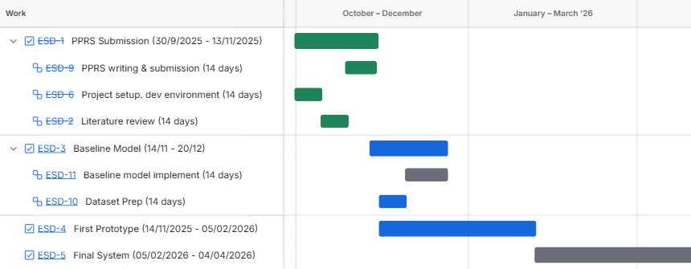
Table 2. Gantt chart timeline

References / Bibliography
- Citations:
    - HSE (2023). Work-related fatal injuries in Great Britain - HSE. [online] Hse.gov.uk. Available at: https://www.hse.gov.uk/statistics/fatals-overview.htm.

    - Hershey, S., Chaudhuri, S., Ellis, D.P.W., Gemmeke, J.F., Jansen, A., Moore, R.C., Plakal, M., Platt, D., Saurous, R.A., Seybold, B., Slaney, M., Weiss, R.J. and Wilson, K. (2017). CNN architectures for large-scale audio classification. [online] IEEE Xplore. doi: https://doi.org/10.1109/ICASSP.2017.7952132.

    - Kong, Q., Cao, Y., Iqbal, T., Wang, Y., Wang, W. and Plumbley, M.D. (2020). PANNs: Large-Scale Pretrained Audio Neural Networks for Audio Pattern Recognition. IEEE/ACM Transactions on Audio, Speech, and Language Processing, [online] 28, pp.2880–2894. doi: https://doi.org/10.1109/taslp.2020.3030497.

    - Elangovan, M., Surrya Prakash, D. and Sasidharan, P. (2021). Monitoring of Workplace Safety Using IoT. Journal of Physics: Conference Series, 2115(1), p.012014. doi: https://doi.org/10.1088/1742-6596/2115/1/012014.
    - Mu, W., Yin, B., Huang, X., Xu, J. and Du, Z. (2021). Environmental sound classification using temporal-frequency attention based convolutional neural network. Scientific Reports, 11(1). doi:https://doi.org/10.1038/s41598-021-01045-4.
    - Tsalera, E., Papadakis, A. and Samarakou, M. (2021). Comparison of Pre-Trained CNNs for Audio Classification Using Transfer Learning. Journal of Sensor and Actuator Networks, 10(4), p.72. doi:https://doi.org/10.3390/jsan10040072.
    - Sonitrol.com. (2025). Verified Audio & Video Intrusion | Sonitrol. [online] Available at: https://www.sonitrol.com/solutions/verified-audio-video-intrusion [Accessed 8 Nov. 2025].
    - March Networks. (2025). AI Series — March Networks. [online] Available at: https://www.marchnetworks.com/products/cameras/ai-series/ [Accessed 8 Nov. 2025].
    - Health, Safety and Vape Detector | HALO Smart Sensor. (n.d.). Health, Safety and Vape Detector | HALO Smart Sensor. [online] Available at: https://halodetect.com/.

    - Hse.gov.uk. (2023). Non-fatal injuries at work in Great Britain - HSE. [online] Available at: https://www.hse.gov.uk/statistics/causinj/overview.htm.

    - Cakir, E., Parascandolo, G., Heittola, T., Huttunen, H. and Virtanen, T. (2017). Convolutional Recurrent Neural Networks for Polyphonic Sound Event Detection. IEEE/ACM Transactions on Audio, Speech, and Language Processing, 25(6), pp.1291–1303. doi:https://doi.org/10.1109/taslp.2017.2690575.

Ethics Form
- The downloaded Ethics Application must be included in this document. The Application must be signed by you and your supervisor BEFORE being included in your submission.

